**DAYALBAGH EDUCATIONAL INSTITUTE**

**Dayalbagh , Agra**

**Smart Green Bicycle parking system**

***Project Report***



**Bachelor of Vocation (IOT)**

**Department of Physics & Computer Science**

**Faculty of Science**

**Dayalbagh Educational Institute**

**Dayalbagh, Agra**

**Declaration**

This is to declare that this report has been written by us. In this project, No part of the plagiarized from other resourse.

All information included from other sources has been deeply acknowledged.

**By Submitted to –**

**Prashant Kumar (1803757) Dr. R.S. Pavithra**

**Sachin Kumar (1803764) Under -**

**Vicky (1803777) Amarjeet Singh Chauhan**

**Abstract**

In the today’s scenario air pollution is the major cause of global warming so that smart green cycle required and that also reduse theft for security purpose & parking problems for a human reliability .We have two areas and each area provide two parking slots .In this project has a GPS module with NodeMCU to show parking in a particular area and IR sensor indicates that parking slot is booked or not even book using (IOT web application) .By the use of website we can lock our cycle smartly so that smart green cycle provide a precious service in different sectors and it is also securable is and this system is east to use.

And in the parking enter only registered cycles using RFID tags. So first the user I’d then they allowed.

**Introduction**

In the present time the technology is more and advanced in the world day by day , so we uses ola cabs technology to travel anywhere in local and long areas but many people can’t use this technology. But by using this project, we can book bicycle easily through web application at the low cost for available. And we also provide a smart lock using Solenoid motor and nodemcu, By using smart lock, Bicycle is smartly lock through web application and make more smart. In this system we use a NodeMCU, and programs are developed in c.

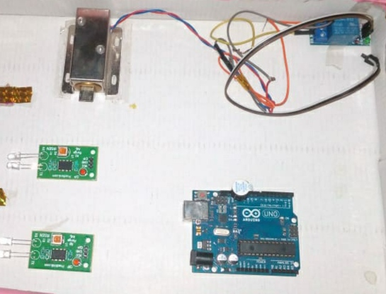

**Apparatus Required –**

* **Nodemcu**
* **Solenoid Motor**
* **Relay Module**
* **12v Battery**
* **IR Sensor**
* **Arduino Uno**
* **Buzzer**
* **Jumper wires etc.**

**Description of Components**

**Nodemcu-**

**It** is an open source IoT platform. It includes firmware which runs on the ESP8266 Wi-Fi SoC from Espressif Systems, and hardware which is based on the ESP-12 module. ... It is based on the eLua project, and built on the Espressif Non-OS SDK for ESP8266. It uses many open source projects, such as lua-cjson and SPIFFS.

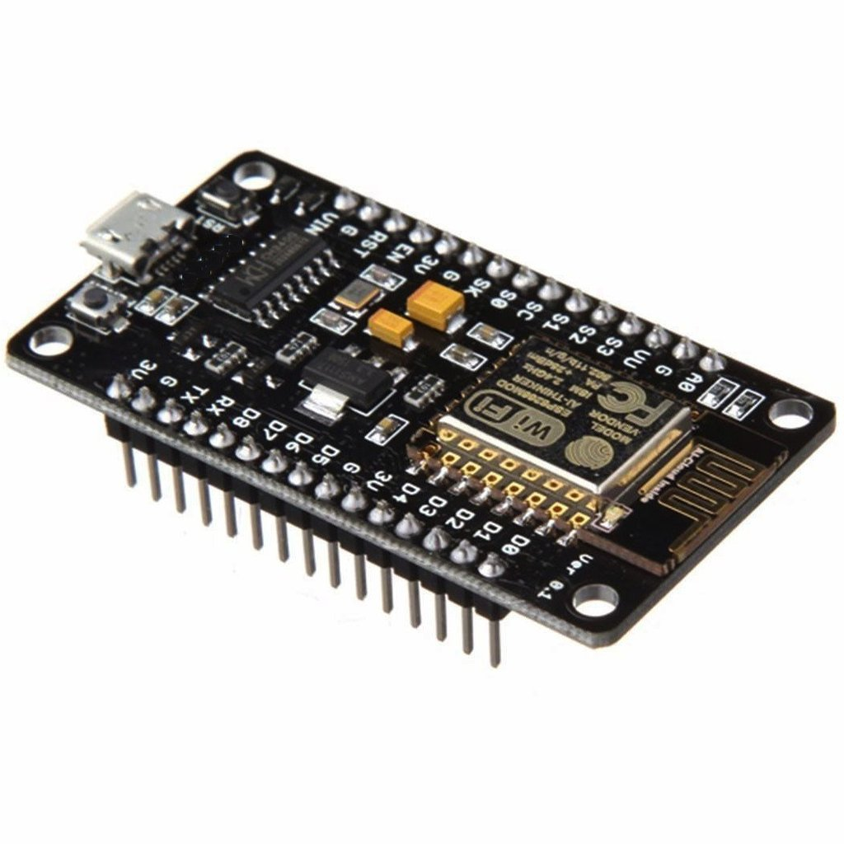

**Solenoid Motor**

**Solenoid lock** has a slug with a slanted cut and a good mounting bracket. It's basically an electronic **lock**, designed for a basic cabinet, safe or door. When 9-**12VDC** is applied, the slug pulls in so it doesn't stick out and the door can be opened.

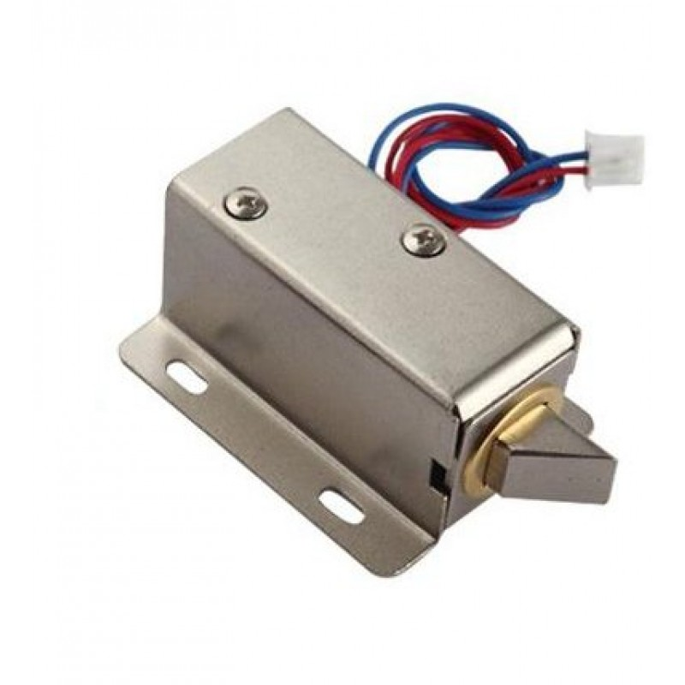

**Relay Module:-**

In this relay, when a current flows through the coil, it turns it into an electromagnet. The magnet pushes a switch to the left, forcing the spring contacts together, and completing the circuit they're attached to. This is a relay from an electronic, hot-water immersion heater programmer.

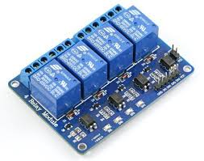

**12v Battery:-**

Nearly all car, motorcycle and tractor **batteries** are **12-volt**, lead-acid **batteries**. These **batteries** can provide hundreds of amps of electrical current for a short period of time. This is why these **batteries** are commonly used in automotive applications.

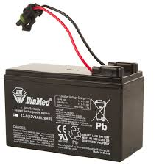

**IR Sensor:-**

An [infrared sensor](https://www.elprocus.com/ir-remote-control-basics-operation-application/) is an electronic device, that emits in order to sense some aspects of the surroundings. An IR sensor can measure the heat of an object as well as detects the motion. These types of sensors measure only infrared radiation, rather than emitting it that is called a [passive IR sensor](https://www.elprocus.com/passive-infrared-pir-sensor-with-applications/). Usually, in the infrared spectrum, all the objects radiate some form of thermal radiation. These types of radiations are invisible to our eyes, that can be detected by an infrared sensor. The emitter is simply an IR LED ([Light Emitting Diode](https://www.elprocus.com/explain-different-types-leds-working-applications-engineering-students/)) and the detector is simply an IR photodiode that is sensitive to IR light of the same wavelength as that emitted by the IR LED. When IR light falls on the photodiode, the resistances and the output voltages will change in proportion to the magnitude of the IR light received.

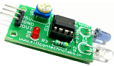

**Arduino Uno:-**

Arduino is an open-source electronics platform based on easy-to-use hardware and software. It's intended for anyone making interactive projects**.**

**Features of the Arduino UNO:**

* **Microcontroller: ATmega328.**
* **Operating Voltage: 5V.**
* **Input Voltage (recommended): 7-12V.**
* **Input Voltage (limits): 6-20V.**
* **Digital I/O Pins: 14 (of which 6 provide PWM output)**
* **Analog Input Pins: 6.**
* **DC Current per I/O Pin: 40 mA.**
* **DC Current for 3.3V Pin: 50 mA.**

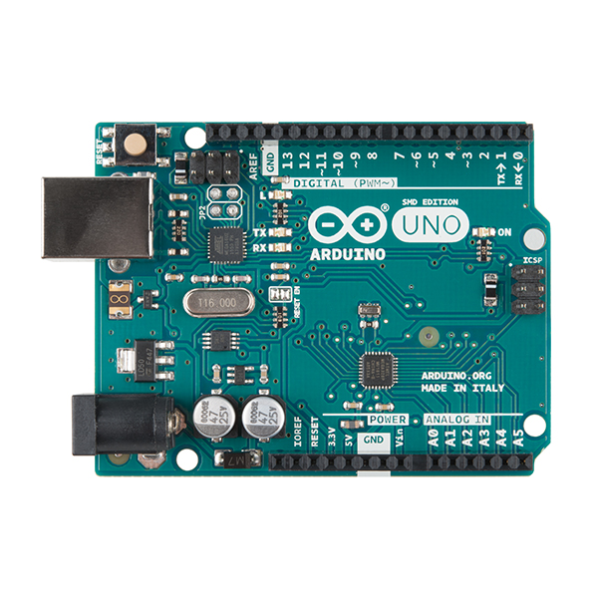

**Buzzer:-**

Piezo **Buzzer** - **5V** - w/ Self Oscillation **Circuit**

It can be operated directly from **5V** DC, unlike other Piezo **buzzers**, it does not require an oscillatory signal or AC signal. It has an inbuilt 2KHz oscillation **circuit** which operates the piezo element to generate audible tone.

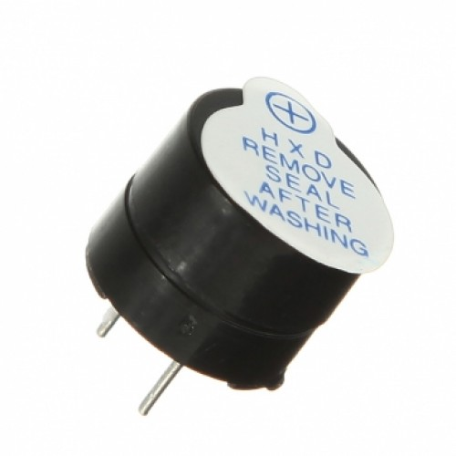

**Jumper wires:-**

The term "jumper wire" simply refers to a conducting wire that establishes an electrical connection between two points in a circuit. You can use jumper wires to modify a circuit or to diagnose problems in a circuit**.**

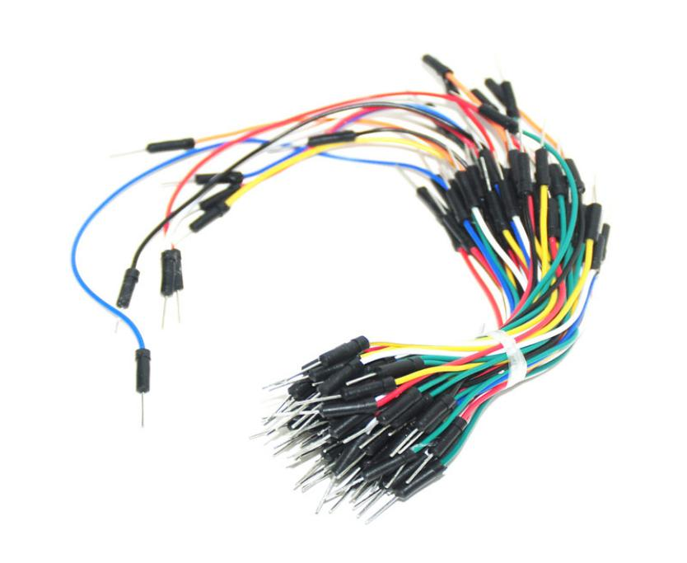

**Steps of Algorithm:-**

**Step 1**- Collect all components, wires and any other equipments For use in this project.

**Step 2**- Connection one by one components with each other.

**Step 3**- Will do wiring for all components.

**Step 4**- Sample Source Code

* Enter the source code for this implementation.

**Step 5**- Result

* Result of this implementation.

**Solenoid lock, Relay module with Nodemcu-**

1. **Introduction**-

Create a smart lock using nodemcu relay module, 12v battery and jumper wires. And using a html code to lock unlock the solenoid motor through web page.

1. **Components-**

* **Solenoid motor**
* **Relay module**
* **12v battery**
* **Nodemcu**

1. **Connnection:-**

**NodeMCU to Relay**

|  |  |
| --- | --- |
| **NodeMCU** | **Relay** |
| **Pin D5** | **Signal** |
| **12v** | **Vcc (+)** |
| **Gnd** | **Gnd (-)** |

**Then connect +ve terminal of battery to the Common (C) of Relay, -ve terminal of battery connect to the Solenoid motor’s black wire and normally Open (NO) of the relay connect to Solenoid motor’s red wire.**

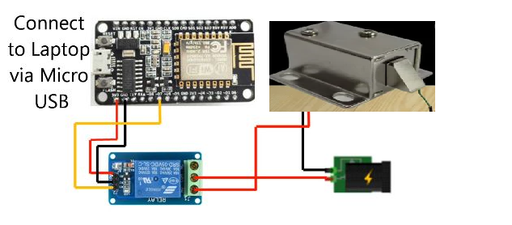

**IR Sensor, Buzzer with Nodemcu**

1. **Introduction:-**

We create this connection to detect that bicycle is available or not. If bicycle is available in any slot, then ir sensor detect and With the help of buzzer it beeps.

1. **Components:-**

* Arduino Uno
* IR Sensor
* Buzzer

1. **Connection:-**

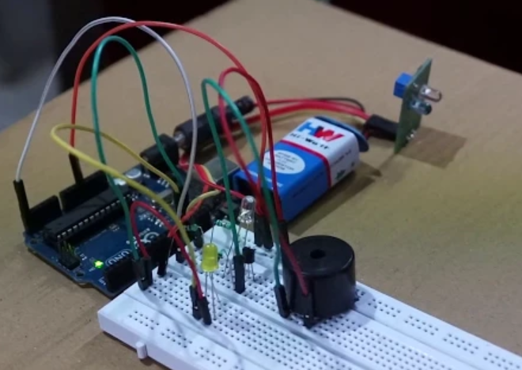

**Advantages –**

* **The main advantage of “the smart cycle” is that the “Reducing the pollution”.**
* **Controlled through one common device**
* **Fast enough to realize the true power of wireless technology and web technology**
* **Provide the reliable parking management mode.**
* **Smart payment.**
* **Security.**

**Disadvantage –**

* **Must use of internet connected devices.**
* **It can’t repair easily.**
* **At that time it is costly.**

**After Complete Project Architecture**

